I have found some weird behaviors at VyOS. They are throughput irregularities which could be related to VyOS version and to the environment VyOS runs in.

I have a central VyOS router (I will call it the Hub), and then I have other VyOS routers surrounding the Hub router (I will call them Spokes).

Each spoke is directly connected to an ethernet interface of the Hub router, and the number of each Hub’s ethernet interface is used to name its connected spoke.

Except for test5, this is the diagram used in tests:
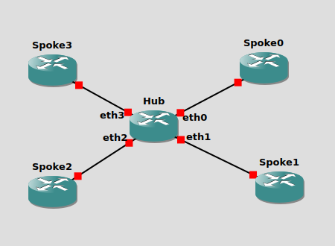

Each Spoke is in a different subnet and they all can talk to each other. All routers are on OSPF. I did a test with static routes, but that made no difference.

There is no configuration but interface addresses and basic routing.

The tests consist in using iperf between every possible pair of nodes.

Having the same hardware, software and configuration, the expected result should show that every pair of spoke give the same throughput as average (when repeating the tests many times). It’d be normal to find random little differences in every test, but the average value should be the same for every pair of spokes.

The weird thing is that, when I measure the traffic throughput between some specific pair of spokes, there are some clear differences in some circumstances. Some specific pairs of spokes unequivocally show a clearly different throughput value than other pairs of spokes. Always, no matter how many times you repeat the test.

I am using the green color for high rates and the red color for low rates in order to highlight the differences and to draw the mysterious pattern they make.

All tests are done using the iperf command.

I don’t think IP addresses of the Hub have any effect in the results, but I am showing them, just in case.

TEST1

Computer: Santi’s laptop with Ubuntu
Emulation software: GNS3
VyOS version: 1.3-rolling-202002120218

Hub Hub
Interface IP Address
------ ----------
eth0 49.143.252.11/24
eth1 10.99.99.1/24
eth2 4.4.4.1/24
eth3 222.222.222.1/24

Please note:
- 2 very different results.

TEST2

Computer: Santi’s laptop with Ubuntu
Emulation software: GNS3
VyOS version: 1.2.5-epa1 LTS

Hub Hub
Interface IP Address
------ ----------
eth0 222.222.222.1/24
eth1 49.143.252.11/24
eth2 10.99.99.1/24
eth3 4.4.4.1/24

Please note:
- 2 moderately different results.
- Different pattern compared to Test1.

TEST3

Computer: Santi’s laptop with Ubuntu
Emulation software: GNS3
VyOS version: VyOS 1.3-rolling-202002120218

Hub Hub
Interface IP Address
------ ----------
eth0 222.222.222.1/24
eth1 49.143.252.11/24
eth2 10.99.99.1/24
eth3 4.4.4.1/24

Please note:
- 2 very different results.

TEST4
Computer: Santi’s laptop with Ubuntu
Emulation software: GNS3
VyOS version: VyOS 1.3-rolling-202002130217

Hub Hub
Interface IP Address
------ ----------
eth0 222.222.222.1/24
eth1 49.143.252.11/24
eth2 10.99.99.1/24
eth3 4.4.4.1/24

Please note:
- 2 very different results.
- Pattern changed again.

TEST5
Computer: Santi’s laptop with Ubuntu
Emulation software: GNS3
VyOS version: VyOS 1.3-rolling-202002130217
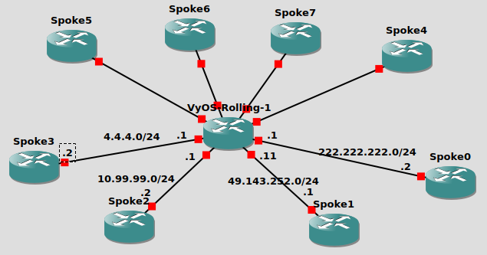

Hub Hub
Interface IP Address
------ ----------
eth0 222.222.222.1/24
eth1 49.143.252.11/24
eth2 10.99.99.1/24
eth3 4.4.4.1/24
eth4 6.6.6.1/24
eth5 7.7.7.1/24
eth6 8.8.8.1/24
eth7 9.9.9.1/24

Please note:
- 2 very different results.
- The pattern seems an extended version of the one of Test4 (and Test1).

TEST6

Computer: Sentrium server
Emulation software: Eve-NG
CPU per node: 1
VyOS version: VyOS 1.2.4 LTS

Hub Hub
Interface IP Address
------ ----------
eth0 192.168.0.1/24
eth1 192.168.1.1/24
eth2 192.168.2.1/24
eth3 192.168.3.1/24

Please note:
- Everything as expected, nothing weird.

TEST 7
Computer: Sentrium server
Emulation software: Eve-NG
CPU per node: 1
VyOS version: VyOS 1.3-rolling-202002150217

Hub Hub
Interface IP Address
------ ----------
eth0 192.168.0.1/24
eth1 192.168.1.1/24
eth2 192.168.2.1/24
eth3 192.168.3.1/24

Please note:
- Throughput dramatically falls down compared to Test6.

TEST8
Computer: Sentrium server
Emulation software: Eve-NG
CPU per node: 4
VyOS version: VyOS 1.3-rolling-202002150217

Hub Hub
Interface IP Address
------ ----------
eth0 192.168.0.1/24
eth1 192.168.1.1/24
eth2 192.168.2.1/24
eth3 192.168.3.1/24

Please note:
- Throughput slightly decreases compared to Test7.

TEST9

Computer: Santi’s desktop with Ubuntu
Emulation software: GNS3
VyOS version: VyOS 1.2.5.epa1

Hub Hub
Interface IP Address
------ ----------
eth0 192.168.0.1/24
eth1 192.168.1.1/24
eth2 192.168.2.1/24
eth3 192.168.3.1/24

Please note:
- 2 moderately different results.

TEST10

Computer: Santi’s desktop with Ubuntu
Emulation software: GNS3
VyOS version: VyOS 1.3-rolling-202002180217

Hub Hub
Interface IP Address
------ ----------
eth0 192.168.0.1/24
eth1 192.168.1.1/24
eth2 192.168.2.1/24
eth3 192.168.3.1/24

Please note:
- 2 very different results.

TEST11

Computer: Santi’s laptop with Ubuntu
Emulation software: GNS3
VyOS version: VyOS 1.2.4 LTS

Hub Hub
Interface IP Address
------ ----------
eth0 192.168.0.1/24
eth1 192.168.1.1/24
eth2 192.168.2.1/24
eth3 192.168.3.1/24

Please note:
- 2 moderately different results.
- Using same VyOS version as Test6, in which everything was correct.

