VyOS v1.4 Packet capture w/ listen-address command
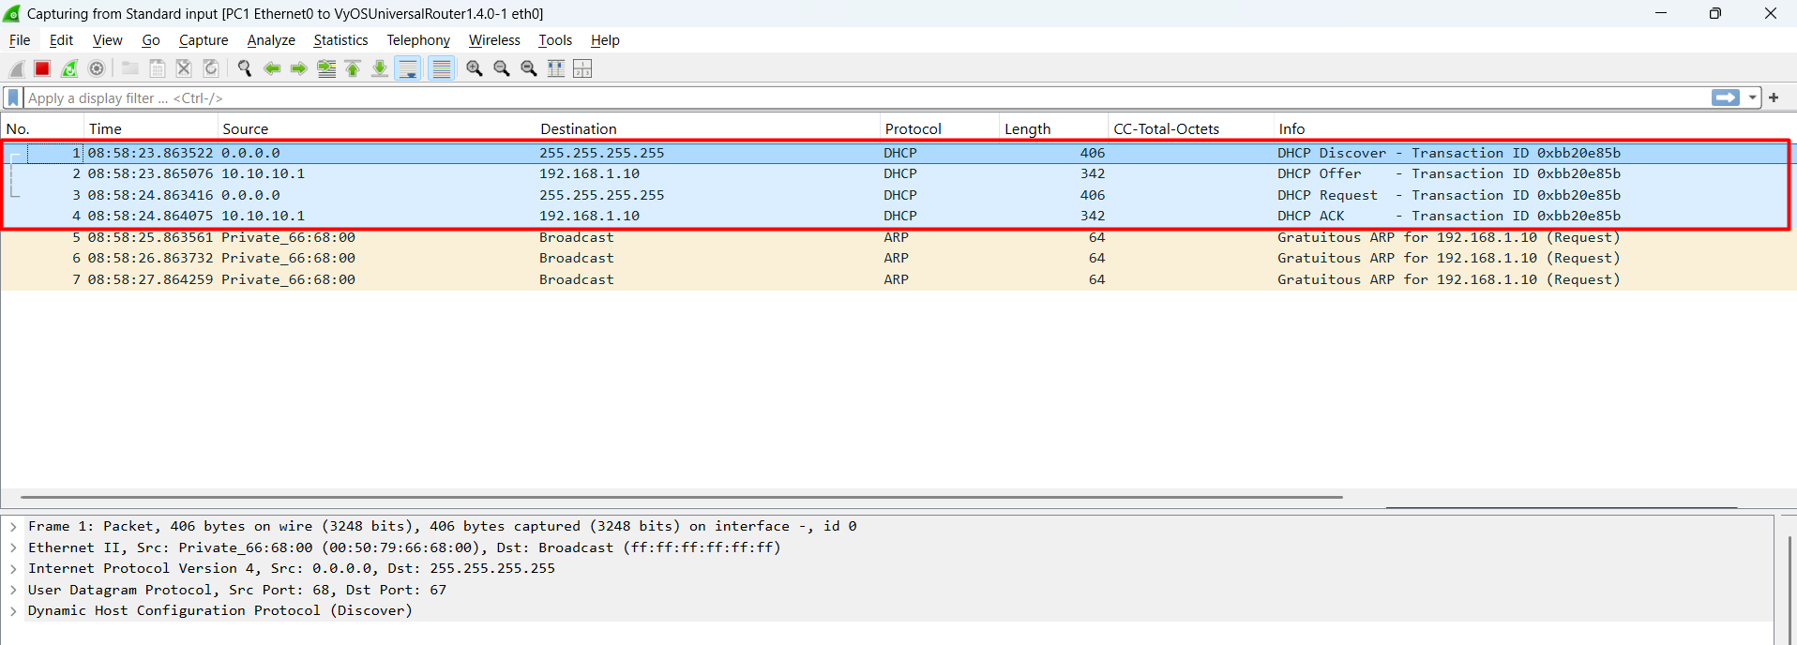
DHCP is working properly; we can see the DORA transaction on the PCAP

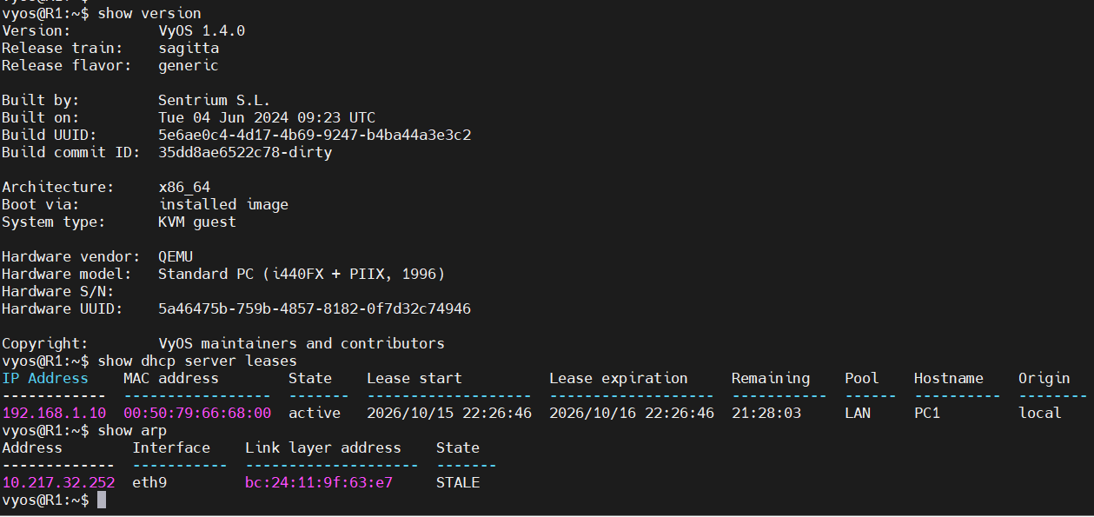

sudo ss -ulnp | grep dhcpd
sudo ss -f link -p | grep dhcpd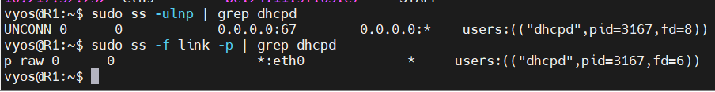

show log dhcp server
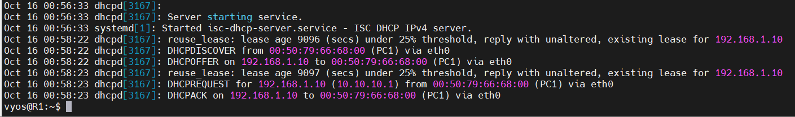
sudo grep -n -E 'subnet|range|listen|interface' /run/dhcp-server/dhcpd.conf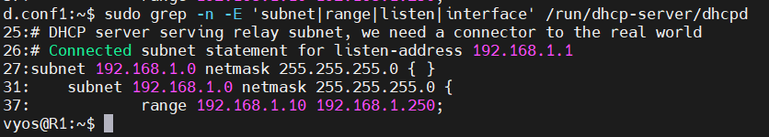
sudo sytemctl status isc-dhcp-server
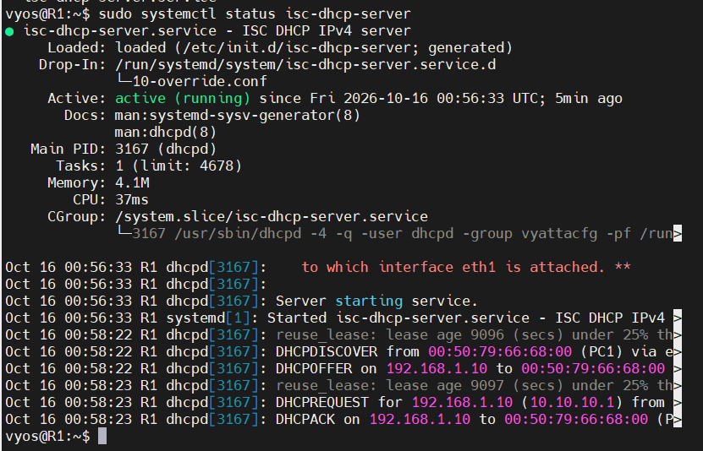
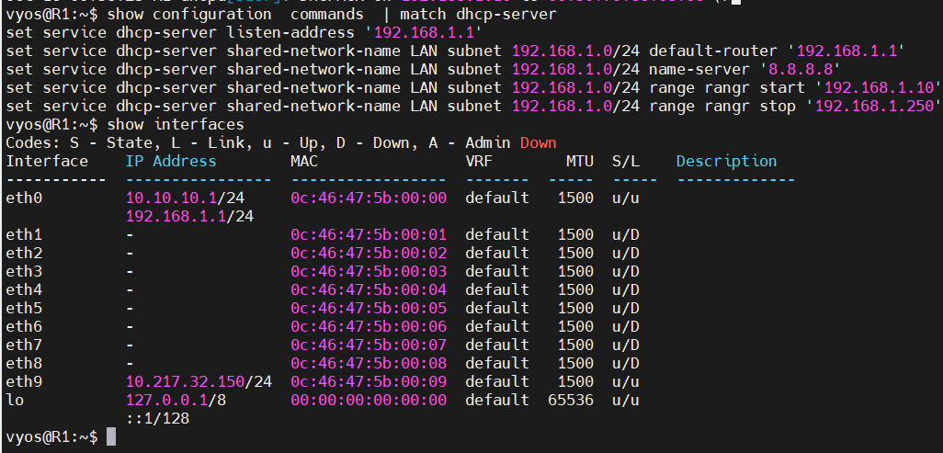
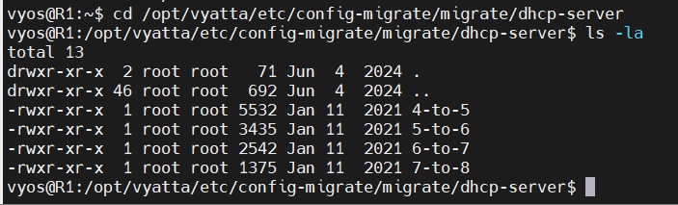

After Upgrading to VyOS 1.5

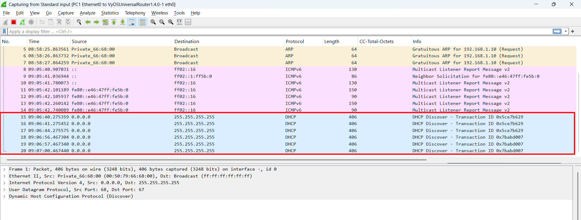
DHCP is not working after the upgrade; we can only see the DHCP Discover
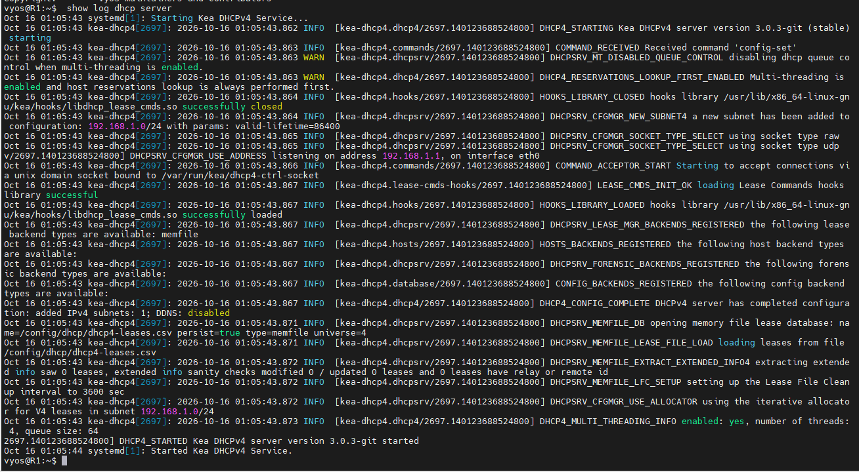
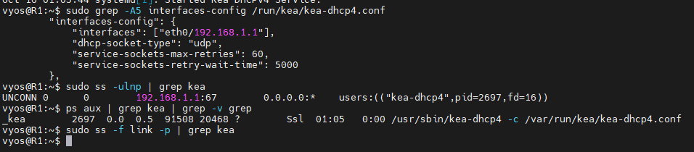
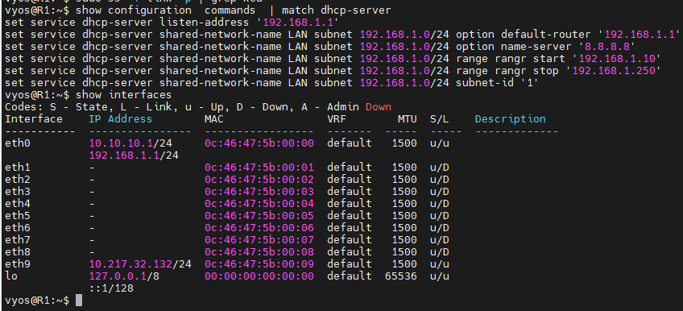
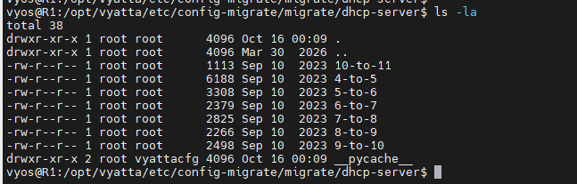

DHCP Migration Script Difference
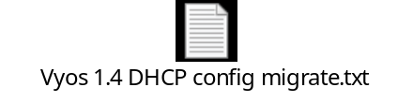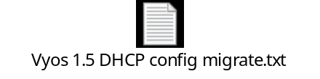
Summary:
After upgrading from VyOS 1.4 to 1.5, DHCP stops working for directly connected clients if the service dhcp-server listen-address is configured. VyOS 1.4 uses ISC DHCP, which handles listen-address with a raw socket, so LAN clients are still served. VyOS 1.5 uses Kea, which switches to UDP-only sockets when listen-address is set ("dhcp-socket-type": "udp"). UDP sockets can’t receive broadcasts from directly connected clients, so only relayed traffic works. The migration script doesn’t handle this: it has no migration from listen-address to listen-interface, so the option is carried over unchanged and breaks DHCP.

